Homework 2

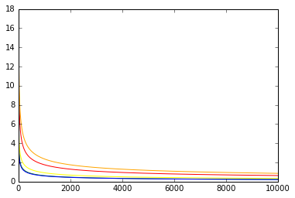

Original vc bound: red

variant vc bound: orange

rademacher penalty bound: yellow

parrondo and van den broek: green

devroye: blue

N=10000

A:

B:

C:

D:

E: